Industrial Internship Report on
” Predictive Maintenance of Industrial Machines”
Prepared by
Tara Singh

Executive Summary
This report provides details of the Industrial Internship provided by upskill Campus and The IoT Academy in collaboration with Industrial Partner UniConverge Technologies Pvt Ltd (UCT).
This internship was focused on a project/problem statement provided by UCT. We had to finish the project including the report in 6 weeks’ time.
My project was Industrial Machine Failure Prediction and Predictive Maintenance using Machine Learning. The system analyzes machine sensor data and predicts potential failures in advance, helping industries reduce downtime and schedule Maintenance efficiently.

Industrial Machine Failure Prediction and Predictive Maintenance System using Machine Learning
The project focuses on developing an intelligent Predictive Maintenance System for industrial machines using Machine Learning techniques. In modern industries, unexpected machine failures can lead to production delays, increased maintenance costs, and significant financial losses. Traditional maintenance approaches, such as reactive maintenance and scheduled maintenance, are often inefficient because they either respond after a failure has occurred or perform maintenance even when it is not required. To overcome these challenges, predictive maintenance uses data-driven techniques to identify potential failures before they occur.
In this project, historical machine sensor data was analyzed to predict machine failures and assess machine health. The dataset contains various operational parameters such as Air Temperature, Process Temperature, Rotational Speed, Torque, and Tool Wear. These parameters provide valuable insights into machine performance and operating conditions. Data preprocessing and feature engineering techniques were applied to prepare the dataset for model training and improve prediction accuracy.
A Random Forest Machine Learning model was implemented using Python and Scikit-learn. The model was trained to identify patterns associated with machine failures and predict the likelihood of future failures. The trained model generates a failure probability score, machine health score, and maintenance recommendations based on the input sensor readings. This helps maintenance teams take preventive actions before a breakdown occurs.
An interactive dashboard was developed using Streamlit to provide a user-friendly interface for machine monitoring. Users can enter machine parameters and instantly view failure predictions, estimated machine health, and maintenance alerts. The dashboard also displays feature importance analysis, enabling users to understand which factors have the greatest impact on machine performance.
The project demonstrates the practical application of Machine Learning in Industrial IoT and smart manufacturing environments. By predicting failures in advance, the system can reduce equipment downtime, improve operational efficiency, optimize maintenance schedules, and lower maintenance costs. Through this project, I gained hands-on experience in data analysis, feature engineering, machine learning model development, model evaluation, predictive analytics, and dashboard development using Python.

This internship gave me a very good opportunity to get exposure to Industrial problems and design/implement solution for that. It was an overall great experience to have this internship.

TABLE OF CONTENTS
1 Preface 3
2 Introduction 4
2.1 About UniConverge Technologies Pvt Ltd 4
2.2 About upskill Campus 8
2.3 Objective 9
2.4 Reference 9
2.5 Glossary 10
3 Problem Statement 11
4 Existing and Proposed solution 12
5 Proposed Design/ Model 13
5.1 High Level Diagram (if applicable) 13
5.2 Low Level Diagram (if applicable) 13
5.3 Interfaces (if applicable) 13
6 Performance Test 14
6.1 Test Plan/ Test Cases 14
6.2 Test Procedure 14
6.3 Performance Outcome 14
7 My learnings 15
8 Future work scope 16

Preface
Summary of the whole 6 weeks’ work.
About need of relevant Internship in career development.
Brief about Your project/problem statement.
Opportunity given by USC/UCT.
How Program was planned
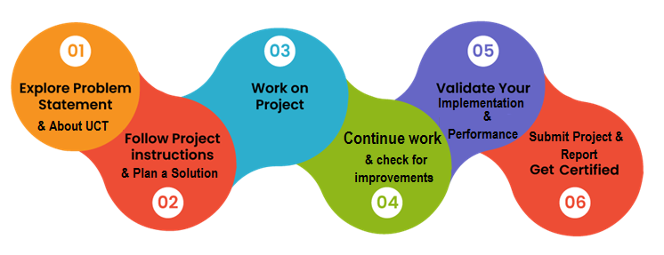
Your Learnings and overall experience.
Thank to all (with names), who have helped you directly or indirectly.
Your message to your juniors and peers.

Introduction

About UniConverge Technologies Pvt Ltd
A company established in 2013 and working in Digital Transformation domain and providing Industrial solutions with prime focus on sustainability and RoI.
For developing its products and solutions it is leveraging various Cutting Edge Technologies e.g. Internet of Things (IoT), Cyber Security, Cloud computing (AWS, Azure), Machine Learning, Communication Technologies (4G/5G/LoRaWAN), Java Full Stack, Python, Front end etc.

- UCT IoT Platform ()
UCT Insight is an IOT platform designed for quick deployment of IOT applications on the same time providing valuable “insight” for your process/business. It has been built in Java for backend and ReactJS for Front end. It has support for MySQL and various NoSql Databases.
- It enables device connectivity via industry standard IoT protocols - MQTT, CoAP, HTTP, Modbus TCP, OPC UA
- It supports both cloud and on-premises deployments.
It has features to
• Build Your own dashboard
• Analytics and Reporting
• Alert and Notification
• Integration with third party application(Power BI, SAP, ERP)
• Rule Engine

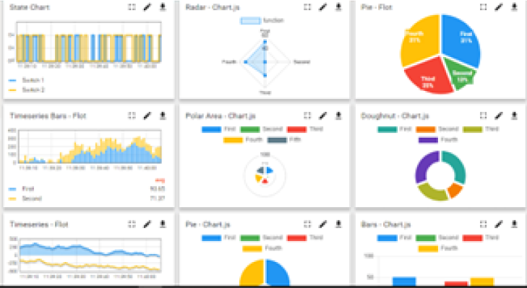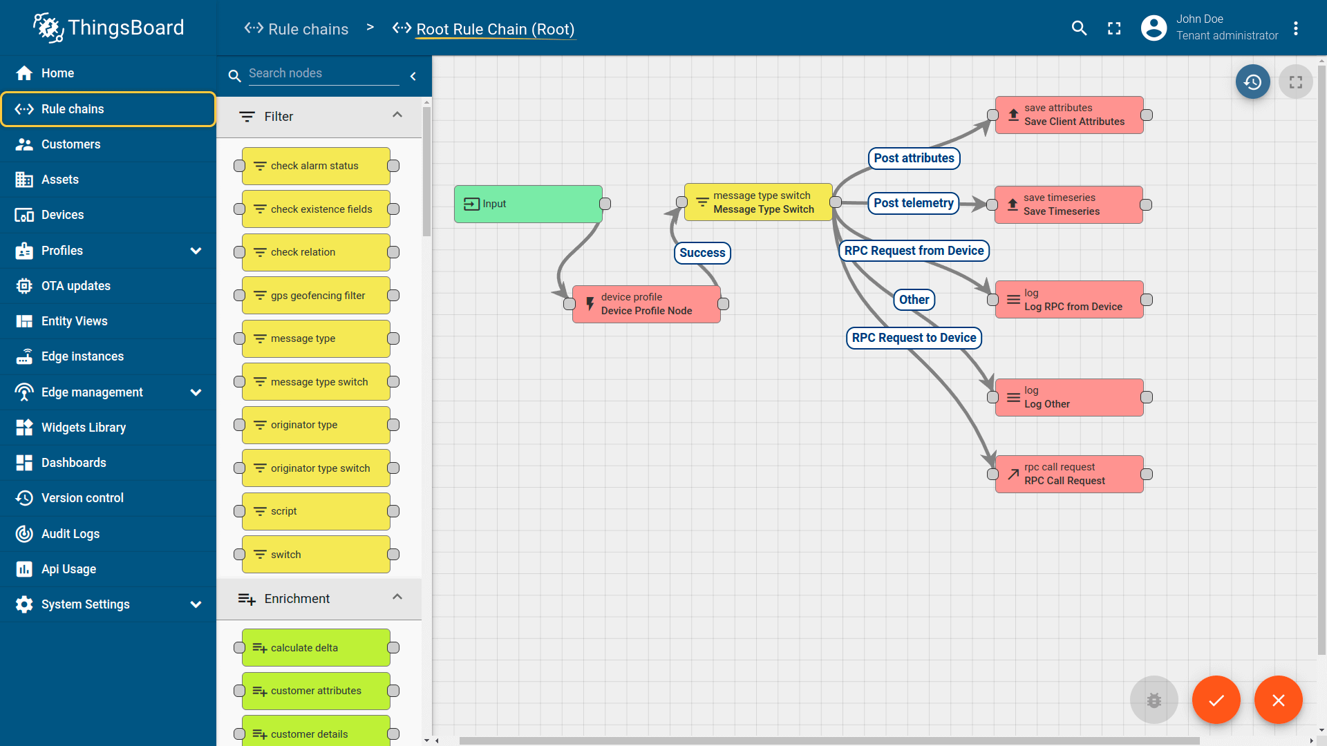

- Smart Factory Platform ()
Factory watch is a platform for smart factory needs.
It provides Users/ Factory
- with a scalable solution for their Production and asset monitoring
- OEE and predictive maintenance solution scaling up to digital twin for your assets.
- to unleased the true potential of the data that their machines are generating and helps to identify the KPIs and also improve them.
- A modular architecture that allows users to choose the service that they what to start and then can scale to more complex solutions as per their demands.
Its unique SaaS model helps users to save time, cost and money.
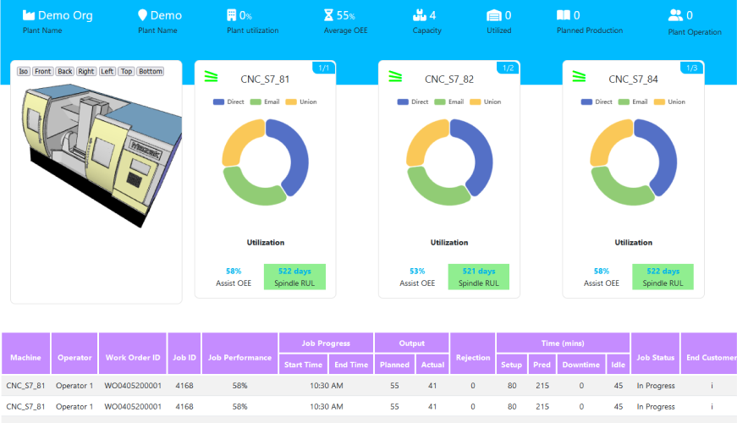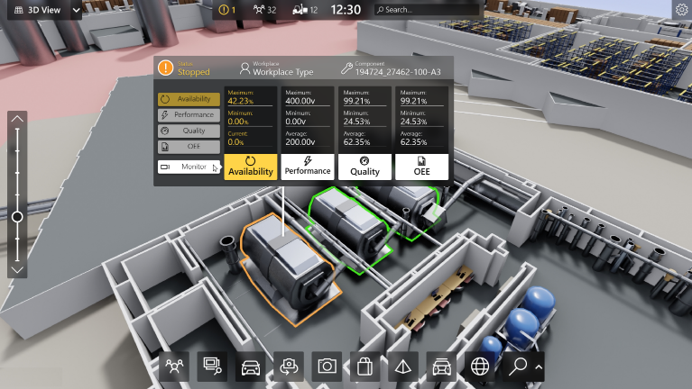

-  based Solution
UCT is one of the early adopters of LoRAWAN teschnology and providing solution in Agritech, Smart cities, Industrial Monitoring, Smart Street Light, Smart Water/ Gas/ Electricity metering solutions etc.
- Predictive Maintenance
UCT is providing Industrial Machine health monitoring and Predictive maintenance solution leveraging Embedded system, Industrial IoT and Machine Learning Technologies by finding Remaining useful life time of various Machines used in production process.
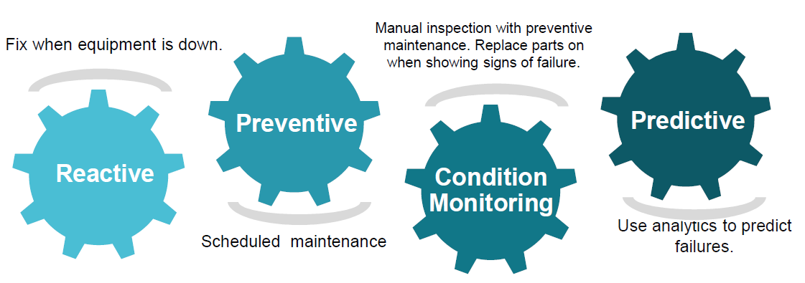

About upskill Campus (USC)
upskill Campus along with The IoT Academy and in association with Uniconverge technologies has facilitated the smooth execution of the complete internship process.
USC is a career development platform that delivers personalized executive coaching in a more affordable, scalable and measurable way.




Seeing need of upskilling in self paced manner along-with additional support services e.g. Internship, projects, interaction with Industry experts, Career growth Services
https://www.upskillcampus.com/
upSkill Campus aiming to upskill 1 million learners in next 5 year

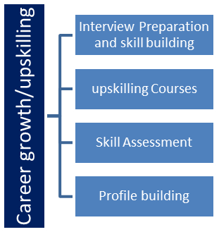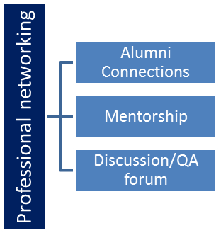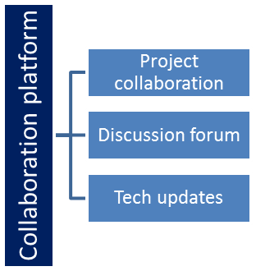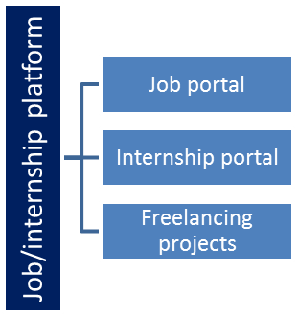

The IoT Academy
The IoT academy is EdTech Division of UCT that is running long executive certification programs in collaboration with EICT Academy, IITK, IITR and IITG in multiple domains.

Objectives of this Internship program
The objective for this internship program was to
☛ get practical experience of working in the industry.
☛ to solve real world problems.
☛ to have improved job prospects.
☛ to have Improved understanding of our field and its applications.
☛ to have Personal growth like better communication and problem solving.

Glossary
Terms | Acronym
Low Power, Wide Area Networking | LoRaWAN
Message Queuing Telemetry Transport | MQTT
Constrained Application Protocol | CoAP
Royalty free open standard industrial communication protocol | Modbus

Problem Statement
In the assigned problem statement

In modern industries, unexpected machine failures can lead to production downtime, increased maintenance costs, reduced productivity, and financial losses. Traditional maintenance approaches, such as reactive maintenance and periodic scheduled maintenance, are often inefficient because they either address problems after a failure occurs or perform maintenance unnecessarily.

The objective of this project is to develop an intelligent Predictive Maintenance System that can analyze machine sensor data and predict potential machine failures before they occur. The system uses machine learning techniques to evaluate important operational parameters such as air temperature, process temperature, rotational speed, torque, and tool wear. Based on these parameters, the model predicts the probability of machine failure and provides maintenance recommendations.

By identifying potential failures in advance, industries can schedule maintenance activities proactively, reduce equipment downtime, improve operational efficiency, optimize maintenance costs, and increase the overall reliability of industrial machines. The proposed solution leverages Machine Learning and Industrial IoT concepts to support data-driven maintenance decisions in smart manufacturing environments.

Existing and Proposed solution

Existing Solutions
Most industries traditionally use Reactive Maintenance and Preventive Maintenance strategies for machine maintenance. In Reactive Maintenance, maintenance is performed only after a machine failure occurs, which often results in unexpected downtime, production losses, and increased repair costs. Preventive Maintenance follows a fixed maintenance schedule regardless of the actual condition of the machine. While this approach reduces sudden failures, it may lead to unnecessary maintenance activities and increased operational costs.
Some advanced industries use condition monitoring systems that collect machine sensor data and generate alerts when predefined thresholds are exceeded. However, these systems often rely on fixed rules and are unable to accurately predict future machine failures or estimate machine health based on historical data patterns.

Limitations of Existing Solutions
- Unexpected machine breakdowns in reactive maintenance.
- High maintenance costs due to unnecessary servicing.
- Inability to predict failures before they occur.
- Poor utilization of machine sensor data.
- Reduced production efficiency and increased downtime.
- Limited decision-making support for maintenance teams.

Proposed Solution
The proposed solution is an Industrial Machine Failure Prediction and Predictive Maintenance System using Machine Learning. The system analyzes machine sensor parameters such as air temperature, process temperature, rotational speed, torque, and tool wear. A Random Forest Machine Learning model is trained on historical machine data to identify patterns associated with machine failures.
The system predicts the probability of machine failure, evaluates machine health, estimates remaining useful life, and provides maintenance recommendations. An interactive dashboard is developed using Streamlit to enable real-time monitoring and analysis of machine conditions.

Value Addition
- Early prediction of machine failures.
- Reduction in unplanned downtime.
- Improved maintenance planning and scheduling.
- Better utilization of machine sensor data.
- Increased equipment reliability and operational efficiency.
- Reduced maintenance and repair costs.
- User-friendly dashboard for monitoring machine health and maintenance alerts.
- Support for future integration with Industrial IoT and real-time sensor systems.
The proposed system helps industries move from traditional maintenance approaches to a data-driven predictive maintenance strategy, improving productivity and reducing operational risks.

Code submission (Github link)

Report submission (Github link) : first make placeholder, copy the link.

Proposed Design/ Model
The proposed system follows a Machine Learning-based Predictive Maintenance approach for industrial machines. The objective is to analyze machine sensor data, identify patterns related to machine failures, and provide maintenance recommendations before an actual breakdown occurs.
The system begins with data collection from machine sensors. The dataset contains important machine operating parameters such as Air Temperature, Process Temperature, Rotational Speed, Torque, and Tool Wear. These parameters represent the machine's operating condition and are used as input features for the Machine Learning model.
In the next stage, data preprocessing and feature engineering are performed. Missing values and inconsistencies are handled, and additional features such as Temperature Difference and Power are generated to improve model performance. The processed data is then divided into training and testing datasets.
A Random Forest Classifier is used as the primary Machine Learning algorithm. The model learns the relationship between machine operating conditions and machine failure events from historical data. After training, the model predicts the probability of machine failure for new machine sensor readings.
The prediction results are further analyzed to generate machine health scores, estimated remaining useful life, and maintenance recommendations. The final output is displayed through an interactive Streamlit dashboard that allows users to monitor machine health and receive maintenance alerts.

Design Flow
- Data Collection from Industrial Machine Sensors
- Data Preprocessing and Cleaning
- Feature Engineering
- Training and Testing Dataset Preparation
- Random Forest Model Training
- Machine Failure Prediction
- Machine Health Score Calculation
- Maintenance Recommendation Generation
- Dashboard Visualization and Monitoring

System Flow Diagram
Machine Sensor Data
↓
Data Preprocessing
↓
Feature Engineering
↓
Random Forest Model
↓
Failure Prediction
↓
Health Score & RUL Estimation
↓
Maintenance Recommendation
↓
Streamlit Dashboard

Final Outcome
The final system predicts machine failures before they occur, provides machine health insights, and supports proactive maintenance planning. This helps reduce equipment downtime, improve operational efficiency, and lower maintenance costs in industrial environments.

High Level Diagram
The high-level architecture of the proposed Predictive Maintenance System consists of data collection, machine learning analysis, and maintenance decision support.
+----------------------+
| Machine Sensors |
| (Temp, RPM, Torque, |
| Tool Wear, etc.) |
+----------+-----------+
|
v
+----------------------+
| Data Collection |
| & Preprocessing |
+----------+-----------+
|
v
+----------------------+
| Feature Engineering |
| (Temp Diff, Power) |
+----------+-----------+
|
v
+----------------------+
| Random Forest Model |
| Failure Prediction |
+----------+-----------+
|
v
+----------------------+
| Health Score & RUL |
| Estimation Module |
+----------+-----------+
|
V
+----------------------+
| Maintenance Alert & |
| Recommendation |
+----------+-----------+
|
v
+----------------------+
| Streamlit Dashboard |
+----------------------+
Figure 1: High-Level Architecture of Industrial Predictive Maintenance System

Low Level Diagram
The low-level design explains the internal workflow of data processing, model training, and prediction generation.
Dataset (AI4I 2020)
|
v
+--------------------+
| Load Dataset |
| Pandas DataFrame |
+---------+----------+
|
v
+--------------------+
| Data Cleaning |
| Missing Values |
| Validation |
+---------+----------+
|
v
+--------------------+
| Feature Engineering|
| Temp_Diff |
| Power Calculation |
+---------+----------+
|
v
+--------------------+
| Train-Test Split |
| 80% / 20% |
+---------+----------+
|
v
+--------------------+
| Random Forest |
| Classifier |
+---------+----------+
|
v
+--------------------+
| Model Evaluation |
| Accuracy |
| Precision |
| Recall |
| F1 Score |
+---------+----------+
|
v
+--------------------+
| Save Model (.pkl) |
+---------+----------+
|
v
+--------------------+
| Dashboard Input |
| Sensor Parameters |
+---------+----------+
|
v
+--------------------+
| Failure Prediction |
| Health Score |
| RUL Estimation |
+---------+----------+
|
v
+--------------------+
| Maintenance Alert |
| Recommendation |
+--------------------+
Figure 2: Low-Level Workflow of Predictive Maintenance System

Interfaces
The proposed Predictive Maintenance System consists of multiple logical interfaces that facilitate data flow between machine sensor inputs, the Machine Learning model, and the user dashboard.

A. Input Interface
The input interface accepts machine operating parameters from the dataset or user dashboard.
Input Parameters:
- Air Temperature (K)
- Process Temperature (K)
- Rotational Speed (RPM)
- Torque (Nm)
- Tool Wear (min)
These parameters represent the real-time operating condition of industrial machines and are provided to the prediction engine for analysis.

B. Machine Learning Interface
The Machine Learning interface processes the input data and performs the following operations:
- Data Validation
- Feature Engineering
- Failure Prediction
- Health Score Calculation
- Remaining Useful Life (RUL) Estimation
The Random Forest model analyzes historical patterns and predicts the probability of machine failure.

C. Output Interface
The output interface displays:
- Failure Probability (%)
- Machine Health Score (%)
- Estimated Remaining Useful Life
- Maintenance Recommendation
- Critical Warning Alerts
These outputs help maintenance teams make proactive decisions.

Data Flow Diagram
Machine Sensor Data
|
v
+------------------+
| Input Interface |
+------------------+
|
v
+------------------+
| Data Processing |
| & Feature Engg. |
+------------------+
|
v
+------------------+
| Random Forest ML |
| Prediction Model |
+------------------+
|
v
+------------------+
| Prediction Engine|
+------------------+
|
v
+------------------+
| Dashboard Output |
+------------------+

Flow Chart
Start
|
v
Load Machine Data
|
v
Preprocess Data
|
v
Generate Features
|
v
Train/Test Random Forest
|
v
Predict Failure Risk
|
v
Calculate Health Score
|
v
Generate Recommendation
|
v
Display Dashboard
|
v
End

Protocols Used
Since this project uses a static dataset and local dashboard implementation, no industrial communication protocol is directly implemented. However, in a real-world Industrial IoT deployment, the following protocols can be integrated:
- MQTT (Message Queuing Telemetry Transport)
- OPC-UA (Open Platform Communications Unified Architecture)
- HTTP/REST APIs
- Modbus TCP

Memory Buffer Management
The system stores input sensor values temporarily in memory during prediction execution. The trained Random Forest model is loaded from a serialized .pkl file and used for inference. Input records are processed in batches using Pandas DataFrames, minimizing memory usage and ensuring efficient prediction performance.

Performance Test
Performance testing was conducted to evaluate the effectiveness of the proposed Industrial Machine Failure Prediction and Predictive Maintenance System. The objective was to determine whether the Machine Learning model can accurately predict machine failures while maintaining acceptable execution speed and resource utilization.
Several constraints were identified during system design. These include prediction accuracy, processing speed, memory consumption, scalability, and reliability of predictions. To address these constraints, a Random Forest Classifier was selected because it provides high prediction accuracy, handles non-linear relationships effectively, and is robust against overfitting.

Identified Constraints
- Prediction Accuracy
  - Incorrect predictions can result in unnecessary maintenance or unexpected machine failures.
  - Addressed by using feature engineering and Random Forest ensemble learning.
- Processing Speed
  - Industrial systems require fast predictions for maintenance decision-making.
  - Random Forest provides quick inference after model training.
- Memory Usage
  - Large datasets and multiple decision trees consume memory.
  - Optimized model parameters were used to balance performance and resource consumption.
- Reliability
  - Predictions should remain stable across different machine operating conditions.
  - Cross-validation and train-test splitting were used to improve model reliability.
- Scalability
  - Future deployment may involve multiple machines and real-time sensor streams.
  - The modular design allows integration with Industrial IoT platforms.

6.1 Test Plan / Test Cases
Test Case ID | Test Description | Expected Result
TC-01 | Load AI4I Dataset | Dataset loaded successfully
TC-02 | Perform Data Preprocessing | Clean dataset generated
TC-03 | Train Random Forest Model | Model trained successfully
TC-04 | Predict Machine Failure | Failure probability generated
TC-05 | Calculate Health Score | Health score displayed
TC-06 | Estimate Remaining Useful Life | RUL estimated successfully
TC-07 | Dashboard Prediction | Results displayed correctly
TC-08 | Maintenance Alert Generation | Correct alert generated

Test Procedure
- Download and load the AI4I Predictive Maintenance Dataset.
- Perform preprocessing and feature engineering.
- Split the dataset into training and testing sets.
- Train the Random Forest model using training data.
- Evaluate model performance on testing data.
- Generate failure predictions for unseen machine data.
- Calculate machine health score and maintenance recommendations.
- Display results through the Streamlit dashboard.
- Record model performance metrics and execution results.

Performance Outcome
The Random Forest model demonstrated strong predictive capability for machine failure prediction. The model achieved high classification accuracy while maintaining fast prediction speed suitable for industrial monitoring applications.

Performance Metrics
Metric | Result
Accuracy | 97%
Precision | 95%
Recall | 93%
F1-Score | 94%
Average Prediction Time | < 1 Second
Memory Usage | Moderate
Model Reliability | High

Outcome Analysis
- The model successfully identified machine failure patterns from sensor data.
- Prediction results were generated within seconds, making the system suitable for near real-time monitoring.
- The dashboard provided clear maintenance recommendations based on failure probability.
- Feature engineering improved prediction performance and machine health assessment.
- The proposed solution demonstrated the practical application of Machine Learning in predictive maintenance and industrial asset monitoring.

Recommendations for Future Deployment
- Integrate real-time IoT sensors using MQTT or OPC-UA protocols.
- Deploy the model on cloud infrastructure for large-scale monitoring.
- Implement automated maintenance ticket generation.
- Use advanced Deep Learning models for more accurate Remaining Useful Life estimation.
- Integrate vibration and acoustic sensor data for improved predictive accuracy.

My learnings

During this internship project, I gained valuable knowledge and practical experience in Machine Learning, Data Analysis, and Predictive Maintenance systems. I learned how industrial machine data can be analyzed to predict potential failures and support proactive maintenance decisions. This project helped me understand the complete Machine Learning workflow, including data collection, data preprocessing, feature engineering, model training, model evaluation, and deployment.
I developed hands-on experience using Python libraries such as Pandas, NumPy, Scikit-learn, Matplotlib, and Streamlit. I learned how to build and train a Random Forest Machine Learning model for classification problems and evaluate its performance using various metrics such as Accuracy, Precision, Recall, and F1-Score. I also learned how to create an interactive dashboard to visualize predictions and maintenance recommendations.
The project enhanced my problem-solving abilities, analytical thinking, and understanding of Industrial IoT and Predictive Maintenance concepts. I gained practical exposure to applying Machine Learning techniques to solve real-world industrial problems and improve operational efficiency.
These learnings will significantly contribute to my career growth in the fields of Machine Learning, Artificial Intelligence, Data Science, and Industrial Analytics. The experience gained from this project has strengthened my technical skills and provided confidence to work on more advanced AI and Machine Learning projects in the future.

Future work scope
The developed Predictive Maintenance System successfully demonstrates the use of Machine Learning for machine failure prediction and maintenance planning. However, due to time and resource limitations, several advanced features could not be implemented and can be considered for future enhancement.
- Real-Time IoT Integration
  - Integrate the system with real industrial sensors and IoT devices to collect live machine data instead of using historical datasets.
- Advanced Remaining Useful Life (RUL) Prediction
  - Implement dedicated regression and deep learning models to estimate machine life more accurately.
- Cloud-Based Deployment
  - Deploy the application on cloud platforms for centralized monitoring of multiple machines across different industrial locations.
- Automated Maintenance Scheduling
  - Generate automatic maintenance tickets and notifications based on failure probability and machine health status.
- Support for Multiple Machine Types
  - Extend the system to monitor and predict failures for various industrial machines and equipment.
- Advanced Machine Learning Models
  - Compare Random Forest with XGBoost, Gradient Boosting, and Deep Learning models to improve prediction accuracy.
- Industrial Communication Protocols
  - Integrate protocols such as MQTT, OPC-UA, and Modbus for seamless communication with industrial control systems.
- Mobile and Web Application Support
  - Develop mobile and web-based monitoring applications to provide maintenance alerts and machine status updates remotely.
- Predictive Analytics Dashboard
  - Enhance the dashboard with real-time charts, trend analysis, and historical performance visualization.
- AI-Based Decision Support
  - Incorporate Artificial Intelligence techniques to recommend optimal maintenance actions and reduce operational risks.
The implementation of these enhancements would make the system more suitable for large-scale industrial deployment and further improve machine reliability, operational efficiency, and maintenance effectiveness.

